

[Date]

Date of Submission: 05/01/2021

Submitted to:

Name: Sumon Saha

Assistant Professor

Dept. of CSE

at Bangladesh University of Business and Technology.

Submitted by:

Name: Syeda Nowshin Ibnat

ID: 17183103020

Intake :39

Section: 01

Program:B.Sc. in CSE

Lab Evaluation

Course Code: CSE 310

Course Title: Operating Systems Lab

1. Q: Create a file year2020 that will contain a calendar from January – December for the year 2020.

Solution:

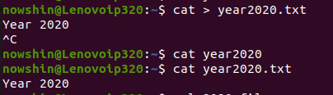

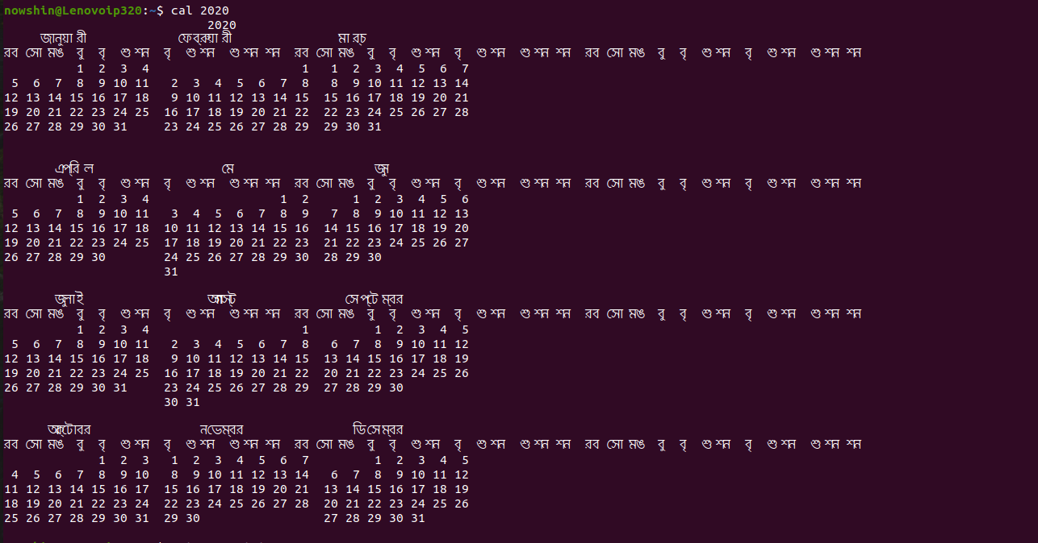

1. Q: List all files whose names begin with the letter g, —have any three characters following the g, —and end with “tly.txt”.

Solution:

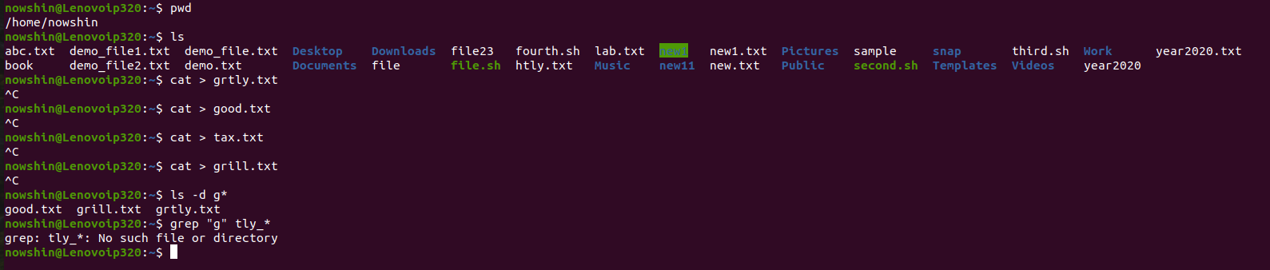

1. Q: Sort the home directory by the size of the file.

Solution:

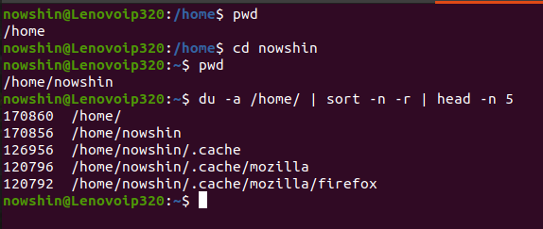

1. Q: Write a shell script sum.sh that takes an unspecified number of command line arguments (up to 9) of ints and finds their sum. Modify the code to add a number to the sum only if the number is greater than 10.

Solution:

